Introduction to Generative AI (Intel AI)
Assignment 01
Part 1: Perplexity AI
Part 2: Video Generation Tools

Name: Kiran T
Reg No.: 23BECS132

Perplexity:
Futuristic Transportation System
By 2085, the city of Neoterra redefines urban mobility through a fully integrated Urban Circulatory Nexus (UCN) — a blend of automation, clean energy, and adaptive infrastructure.
At its heart lies the SkyLoop, a network of aerial magpods gliding silently through electromagnetic lanes suspended above skyscrapers. These pods use dynamic-routing algorithms and communicate through 6G+ quantum mesh networks, adjusting in real time to population movement, weather, and emergencies.
Below ground, hyper-speed maglev tunnels connect city sectors through sealed vacuum tubes, cutting cross-city travel to under three minutes. The Surface Mobility Grid is reserved for pedestrians, cyclists, and micro-vehicles powered by kinetic energy harvesting pavements. Every motion — even a footstep — contributes to the city’s power reserve.
Pollution is nearly extinct thanks to biofiltration towers and algae-based oxygen farms that line the transportation corridors. AI-managed logistics eliminate congestion entirely by synchronizing transport flow and predicting demand patterns 20 minutes in advance.
Neoterra’s transportation system is no longer just a network of movement — it is a living organism, constantly adapting, learning, and breathing clean life into the city it sustains.

Short Story: The Hourglass Directive
Time was never silent for Kael Linford. Each tick of his chrono-band echoed a warning from the Temporal Preservation Authority — “Observe, record, never change.”
Kael was a Chrononaut, one of the few authorized to traverse history for documentation and study. His mission today: witness the Great Manhattan Blackout of 2089. He stood among civilians, invisible to their eyes, watching panic ripple through streets he knew too well. In one alley, a girl stumbled — the same girl who would later grow up to become his mother.
His pulse quickened. He knew every rule: no interference, no contact, no voice. Yet, as she fell toward a pool of live wires, instinct screamed louder than logic. One step forward, and his chrono-band glowed red, vibrating violently. “Do not alter causality,” the voice of the Authority repeated in his mind.
He stopped. Pain coursed through him as he watched fate unfold exactly as recorded. He was bound by time’s cruel law — the knowledge to prevent tragedy, but forbidden to rewrite it. When he returned to the present, tears blurred his vision as the Authority logged his emotional instability for review.
Kael realized then that history was not built by heroes — it was built by those who endured the unbearable act of doing nothing.

Dialogue — Stranded on a Deserted Island
- Rina: “It’s almost beautiful, isn’t it? The silence.”
- Liam: “Beautiful? We’re stuck here with no food, no signal, and no sign of rescue.”
- Rina: “Maybe that’s the point. The world kept shouting at us — deadlines, targets, noise. Maybe it’s time we listen to something else.”
- Liam: “You’re romanticizing disaster.”
- Rina: “Maybe. Or maybe, this is what freedom actually looks like — raw, untamed, and terrifying.”
- Liam: “If freedom means starving, I’ll take my old desk job back.”
- Rina: “Then you haven’t learned the lesson yet.”

Genmo ai
A cute robot exploring a futuristic city at night, neon lights reflecting off wet streets, flying cars passing overhead, cinematic lighting, smooth camera pans, in Pixar-style animation.
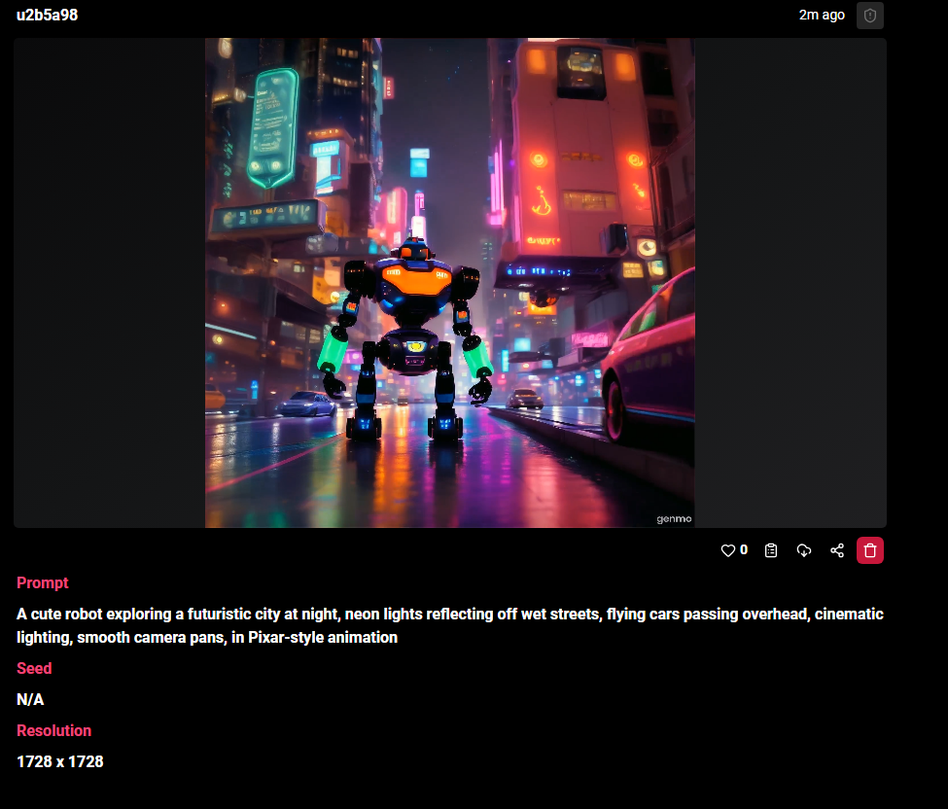

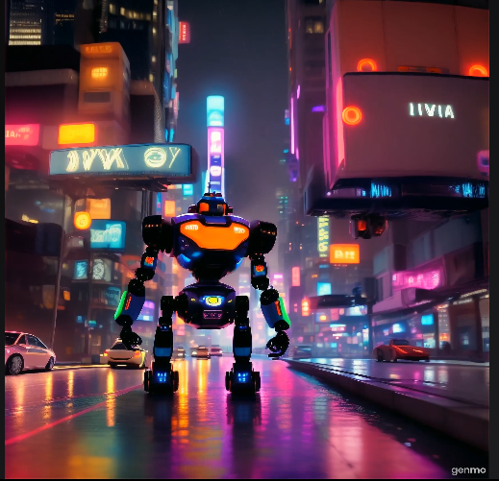

Runway ai
atmosphere, camera orbit around team, natural daylight through glass walls, crisp and modern tone.
